**LIT ASSIGNMENT -DAY 12**

**Name : Bharat Pratap Singh**

**EMPLOYEE ID – 46255429**

Interface:

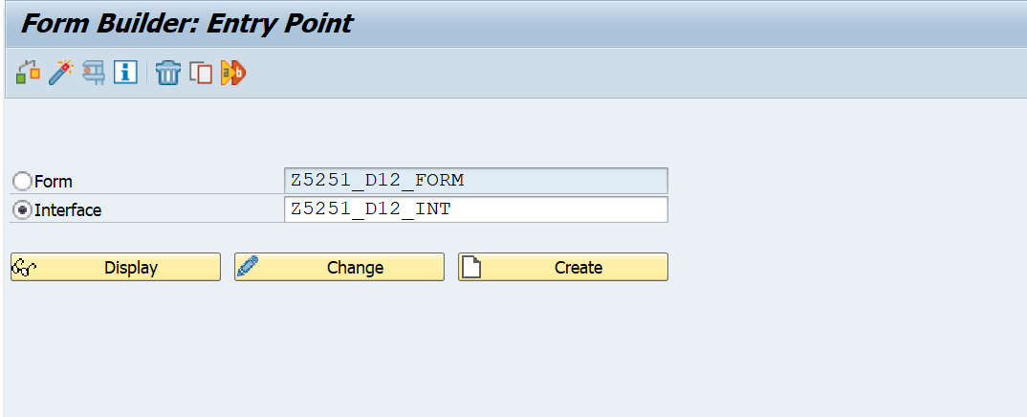

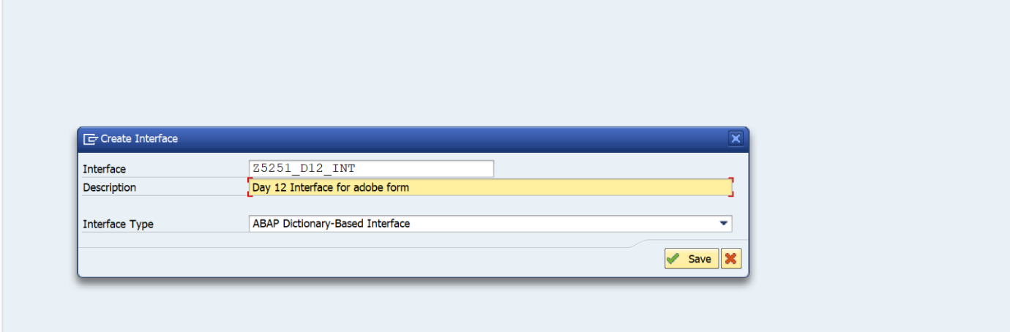

Declaring dynamic text:

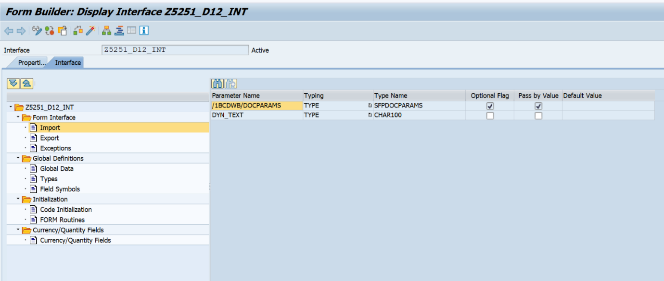

se78- uploading image

Global data in interface:

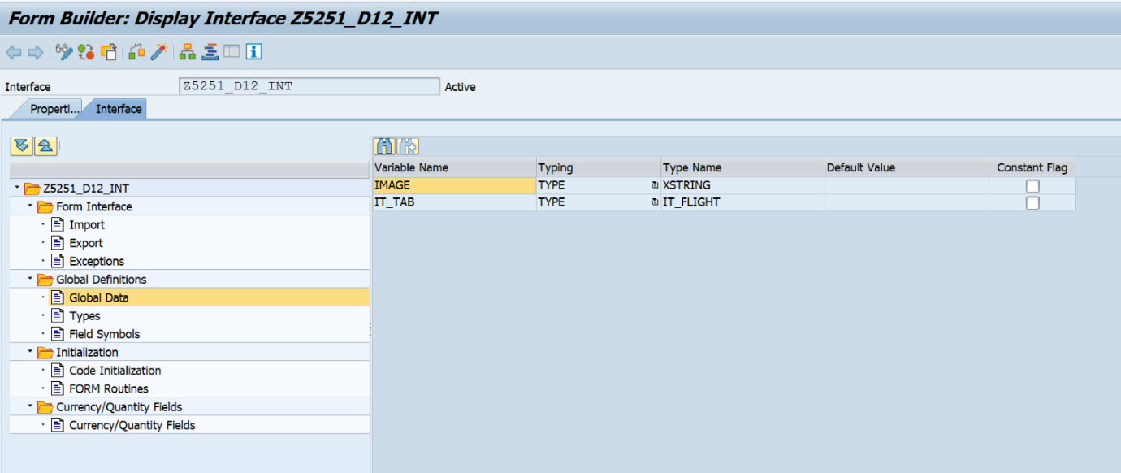

Structure and table type:

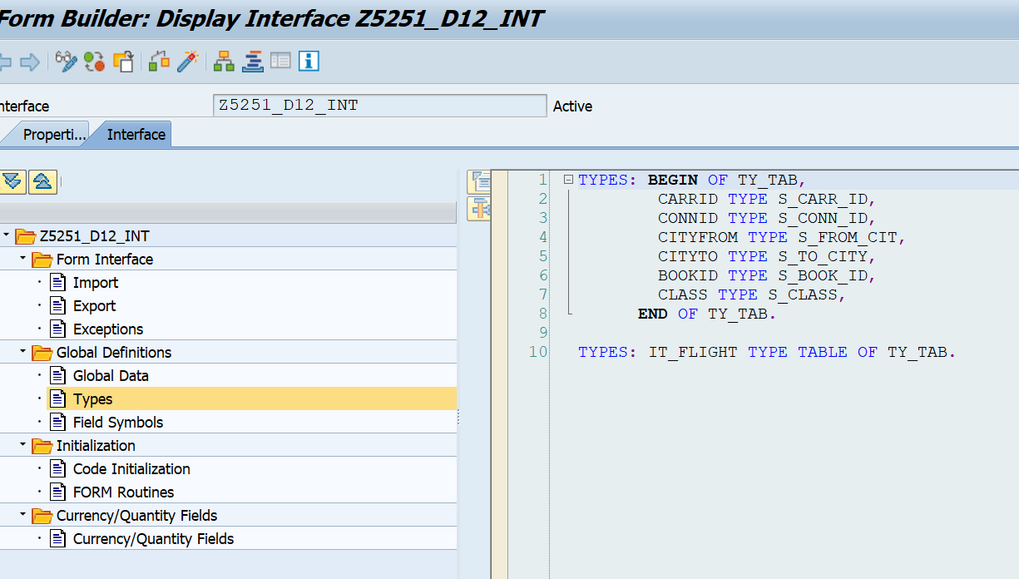

Code initialization:

CALL METHOD CL_SSF_XSF_UTILITIES=>GET_BDS_GRAPHIC_AS_BMP   
  EXPORTING   
    P_OBJECT       = 'GRAPHICS'   
    P_NAME         = 'CG'   
    P_ID           = 'BMAP'   
    P_BTYPE        = 'BCOL'   
  RECEIVING   
    P_BMP          = IMAGE   
  EXCEPTIONS   
    NOT_FOUND      = 1   
    INTERNAL_ERROR = 2   
    OTHERS         = 3   
        .   
IF SY-SUBRC <> 0.   
*\* Implement suitable error handling here*   
ENDIF.   
   
   
  SELECT   
   
  A~CARRID  A~CONNID B~CITYFROM B~CITYTO C~BOOKID C~CLASS   
  FROM SFLIGHT AS A INNER JOIN SPFLI AS B ON A~CARRID EQ B~CARRID   
  INNER JOIN SBOOK AS C ON B~CARRID EQ C~CARRID INTO TABLE IT_TAB UP TO 50 ROWS.

Form:

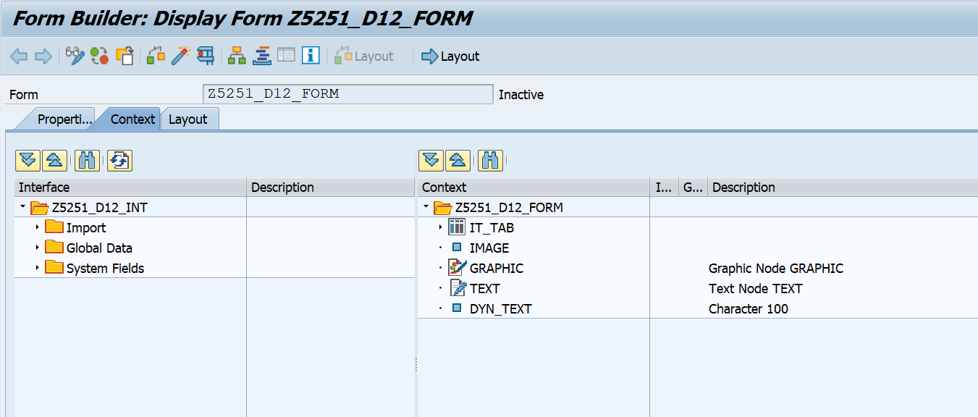

Code for header in only first page:

var curpage = $layout.page ( ref ( $ ) )

       if ( curpage ne 1 ) then

       $.presence = "hidden"

       endif

Code for footer in only last page:

var curp = $layout.page ( ref ( $ ) )

        var totalp = $layout.pageCount()

        if ( curp ne totalp ) then

        $.presence = "hidden"

        endif

Layout:

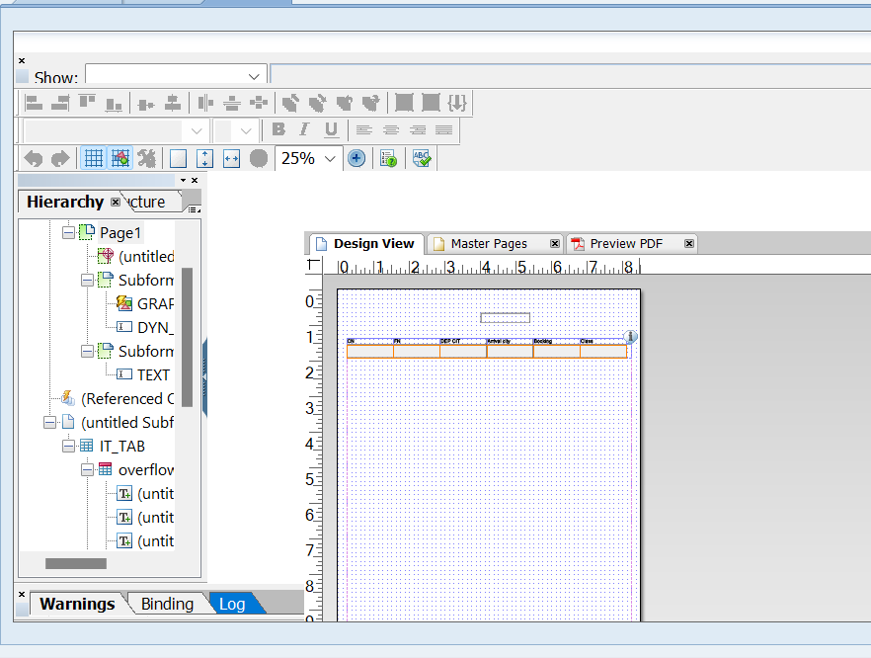

Adobe form output:

